** Even Semester (2018)**

**BINUS UNIVERSITY BINUS INTERNATIONAL**



|  |  |  |  |
| --- | --- | --- | --- |
| **Student Information**: | ***Surname*** | ***Given Names*** | ***Student ID Number*** |
| *1.* **Ashadi** | | **Arkaan** | **2101718425** |
| *2.* **Bismadhika** | | **Fiqhy** | **2101714824** |
| *3.* **Yamin** | | **Farras** | **2101704584** |
|  | |  |  |
| **Course Code** | **:CHAR6505** | **Course Name** | **: Computer Graphics** |
| **Lecture Class** | **:L4BC-LEC** | **Name of Lecturer** | **: Mr. Raymond Kosala** |
| **Lab Class** | **:B4BC-LAB** | **Name of Lab Teacher** | **: Mr. Andreas Kurniawan** |
| **Major** | **:Computer Science** |  |  |
| **Title of Assignment** | :**Final Project Report** |  |  |
| (if any) |  |  |  |
| **Type of Assignment** | **:Final Project Report** |  |  |
| **Submission Pattern** |  |  |  |
| **Due Date** | **: July 2019** | **Submission Date** | **: 2 July 2019** |

The assignment should meet the below requirements.

1. Assignment (hard copy) is required to be submitted on clean paper, and (soft copy) as per lecturer’s instructions.
2. Soft copy assignment also requires the signed (hardcopy) submission of this form, which automatically validates the soft copy submission.
3. The above information is complete and legible.
4. Compiled pages are firmly stapled.
5. Assignment has been copied (soft copy and hard copy) for each student ahead of the submission.

**Plagiarism/Cheating**

BiNus International seriously regards all forms of plagiarism, cheating and collusion as academic offenses which may result in severe penalties, including loss/drop of marks, course/class discontinuity and other possible penalties executed by the university. Please refer to the related course syllabus for further information.

**Declaration of Originality**

By signing this assignment, we understand, accept and consent to BiNus International terms and policy on plagiarism. Herewith we declare that the work contained in this assignment is our own work and has not been submitted for the use of assessment in another course or class, except where this has been notified and accepted in advance.

**COMPUTER GRAPHICS**

**FINAL PROJECT REPORT**



**Lecturer:**

**Mr. Raymond Kosala**

**Lab Teacher:**

**Mr. Andreas Kurniawan**

|  |  |
| --- | --- |
| **Submitted by:** |  |
| **Arkaan N Ashadi** | **2101718425** |
| **Fiqhy Bismadhika** | **2101714824** |
| **Farras Yamin** | **2101704584** |
|  |  |
|  |  |

**COMPUTER SCIENCE**

**BINUS INTERNATIONAL UNIVERSITY**

**JAKARTA**

**2019**

### Application Description

The application purpose is to simulate a museum/tourism site using a drone perspective to navigate. The application allows the user to control a drone with a first person view or third-person view and switch between two scenes/map. One of the maps also include music that is triggered by a “Music” button.

### Contributions of every group

* Arkaan: Load Map and initialize Drone, Scene switching, Point of view switching
* Fiqhy: Drone’s Movement, Camera, Collisions
* Farras: GUI, report

### Models and Texture

* Drone model with built-in texture.
* Room map babylon file for initial scene
* City map babylon file for alternate scene.
* Eiffel tower object with metal texture.

### Third Party API Framework

In term of API we use Babylon.js.

### Interactivity Support

* Use mouse to move camera.
* Use W, A, S, D keys to move the drone.
* Use Shift and C keys to move up and down.
* “Help” button to show help.
* “Switch” button to switch between 2 maps.
* “Music” button to play a music.
* “Change View” to change the camera perspective.

### 

### User Manual

User can move the drone using WASD to move around and Shift, C to move up and down

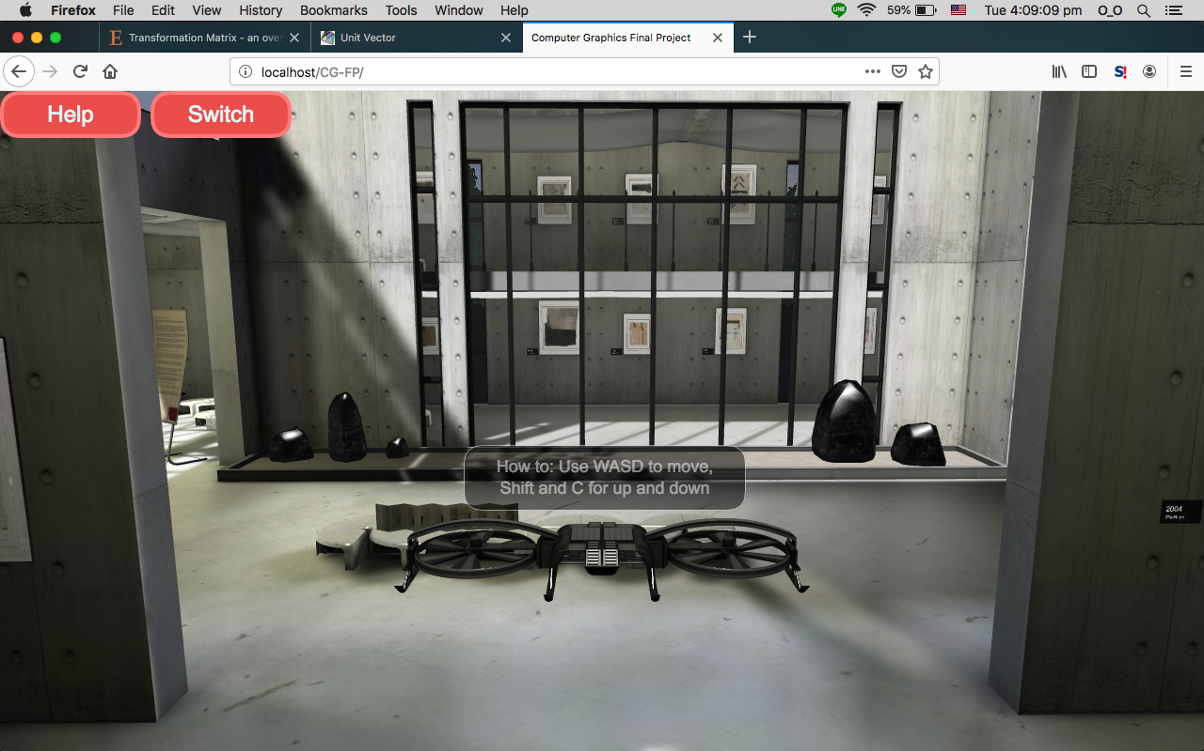

User can close the help menu by pressing the “Help” button on the top left of the screen

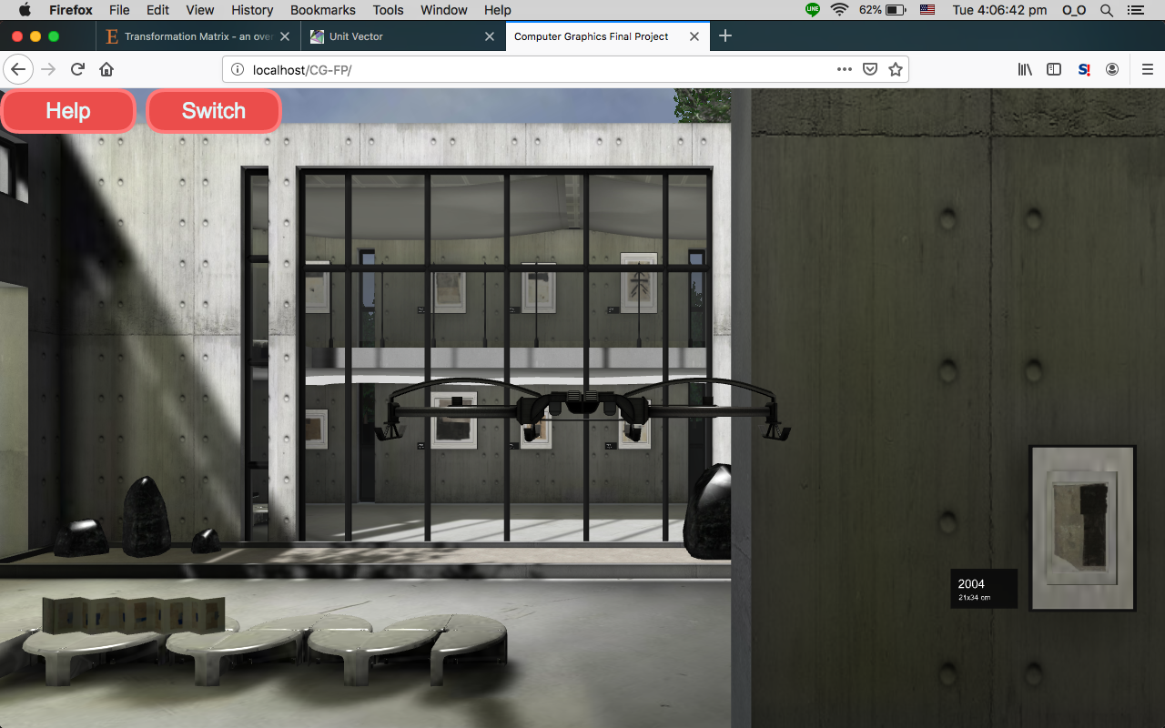

Pressing the switch button will change the map, the music button will play music

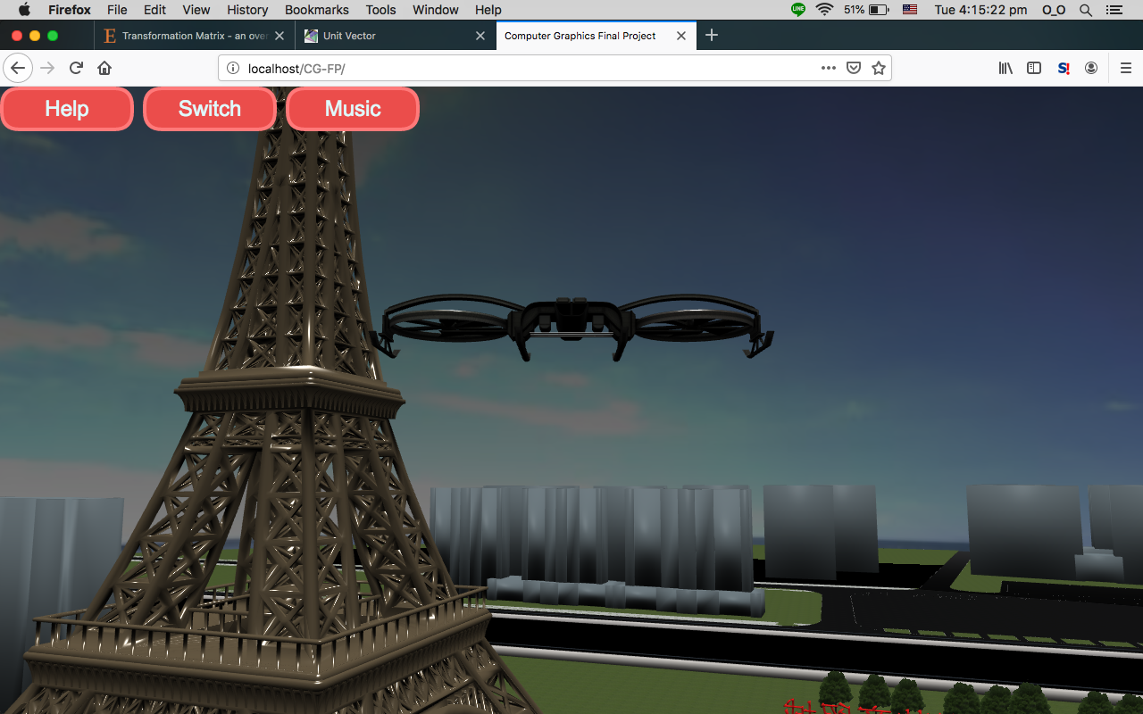

The change view button will change the perspective of the camera between third-person view and first person view.

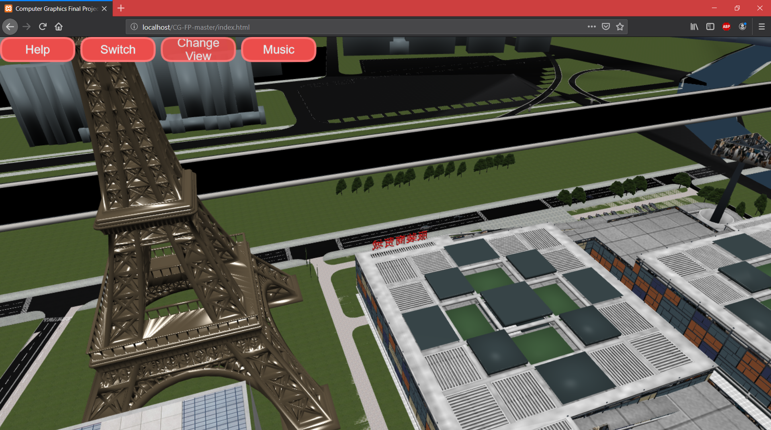

### References

<https://free3d.com/3d-model/controllable-drone-blender-game-engine-67381.html>

TA building babylon file

<https://clara.io/view/8395367a-9f97-4b7f-92d8-851277024b71>